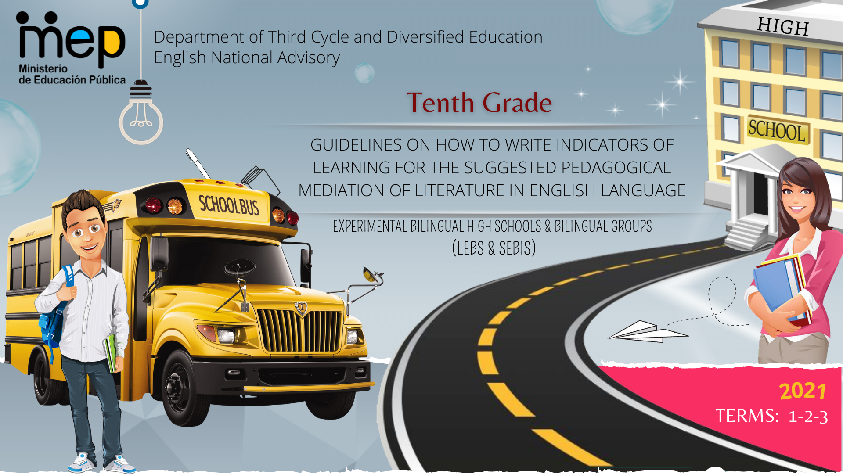

**Autoridades**

**Giselle Cruz Maduro**

Ministro de Educación Pública

**Melania Brenes Monge**

Viceministra Académica de Educación

**María Alexandra Ulate Espinoza**

Directora de la Dirección de Desarrollo Curricular

**Rigoberto Corrales Zúñiga**

Jefe del Departamento de Tercer Ciclo y Educación Diversificada

**Comisión redactora**

**Mag. Marianella Granados Sirias,**

Asesora Nacional de Inglés, Departamento de Tercer Ciclo y Educación Diversificada

**Mag. Alfredo Ortega Cordero**,

Asesor Nacional de Inglés, Departamento de Tercer Ciclo y Educación Diversificada

**Mag. Andrea Cruz Badilla**

Asesora Nacional de Inglés, Departamento de Tercer Ciclo y Educación Diversificada

**Comisión validadora**

Ivannia Arias Zúñiga. Sección Bilingüe Español-Inglés Liceo de Sinaí

Félix Díaz Castañeda, Sección Bilingüe Español-Inglés Liceo de Nicoya

Karen Pereira Meneses, Liceo de Costa Rica

Ana Lucía Ramírez Rodríguez, Liceo de Costa Rica

David Valerio Sánchez, Liceo de Costa Rica

Juliana Sánchez Sánchez, Sección Bilingüe Español-Inglés Liceo San Rafael

Roberto Segnini Cabezas, Sección Bilingüe Español-Inglés Liceo de Colorado

Luis Diego Soto Delgado, Sección Bilingüe Español-Inglés Liceo de Higuito

**Diseño de portada**

**Noelia González Cascante**

Dirección Regional de Educación Guápiles

**Table of Contents**

1. Presentation …………………………………………………………………………………………………………………….5
2. Aims of the document …………………………………………………………………………………………………….……5
3. Important points to keep in mind when working with the Literature in English Language Program……………………6
4. About the indicators for the pedagogical mediation ....................................................................................................8
5. 10th Grade Performance Indicators for the Pedagogical Mediation ………………………………………………...…..12
6. Important Considerations………………………………………………………………………………………………..……13
7. Suggested Performance Indicators for the Pedagogical Mediation Term 1, 2, 3..……….………………….………...14
8. References ……………………………………………………………………………………………….…………..……..…18

**Presentation**

**Dear teachers:**

These guidelines intend to provide you, Literature teachers of tenth grade, with important information on how effectively write indicators to help you to plan your lessons and create assessment instruments for their Self-Study Guides (GTA) and the assessment promotion strategy or *estrategia de promoción* in Spanish. All the indicators will help teachers to measure the performance indicators set in the Literature in English Language curriculum. We believe that you know your students best and therefore we encourage you **to adapt and contextualize** what you find here so that it responds to the needs of your learners. Remember to visit the following link with supplementary resources for your lessons.  https://recursos.mep.go.cr/lebs_y_sebi/:

**Aims of this document:**

1. To give teachers a brief explanation on how to write indicators of learning for planning their Self-Study Guides (GTA in Spanish).
2. To recommend a list of suggested performance Indicators for the pedagogical mediation to teach Literature in English Language in Tenth Grade.

Best,

English Secondary National Advisors

**Important points to keep in mind when working with the Literature in English Language Program.**

* Literature should connect with life experiences, beliefs, and convictions, which have to be faced through a methodological approach of ethical dilemmas (daily life, artistic, fictitious and historical) within a new democratic perspective.
* Literature constitutes a valid opportunity to promote the use of critical and creative skills in the process of building up a classroom community of inquiry, adapted by teachers, according to the learner´s interest and level of English.
* Literature is an invitation to a dialogue. It teaches about humanity and reveals pros and cons of characters in specific situations and times. Learning a language is also learning about culture and values.
* Literature mirrors our own lives and provides a window into distant places, times, and people.
* Reading literature can increase the chances of students becoming passionate readers, who read with a purposeful objective, as well as enjoyment. Additionally, students can improve other skills through literature. As an illustration, creativity and reflection can be reinforced as students perform, write, and analyze different literary texts. Perhaps, this is the ultimate reason that students have for writing with joy and pleasure; that is, their education will be going beyond the reading.

Programa de Literatura en Lengua Inglesa Liceos Experimentales Bilingües, 2011, MEP

**About the indicators for the pedagogical mediation…**

When working with the Literature in the English Language program, teachers need to design their own teaching procedures, in the mediation activities, on the basis of the learners’ pre-and post-assessments, as well as performance and reaction to instructional practices, circumstances and interests of each class community. The use of a rich variety of techniques and activities in the class will lead the students to establish positive cross curricular connections with suggested and flexible literature contents and within a socio-constructivist curricular approach. Consequently, visualizing, planning, and implementing techniques relevant to student-need and selecting coherent activities with the method, and in harmony with the approach, is the teacher’s job. In regard to the performance indicators for the pedagogical mediation, they are used to assess the activities proposed during the pedagogical mediation process. Performance indicators for the pedagogical mediation are strictly related to the activity’s achievement, and they help to provide specific and timely descriptive feedback to students.

It is important to clarify that this document includes only performance indicators that are measurable, observable and specific. However, we ask teachers to pay special emphasis on the following observable behaviors since they are as equally important because of nature and purpose of this subject:

* Appreciate and enjoy intermediate oral and written literary pieces.
* Appreciate and enjoy myths, movies, and novels.
* Value authors ‘literary contributions.
* Demonstrate development of social strategies.
* Understand meaning in different context.
* Apply collaborative work and learning strategies (outline, graphic organizers, etc.).

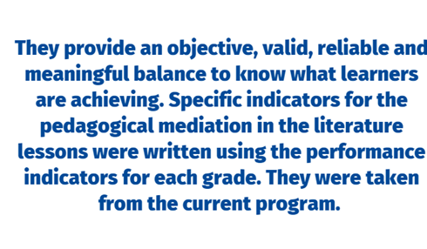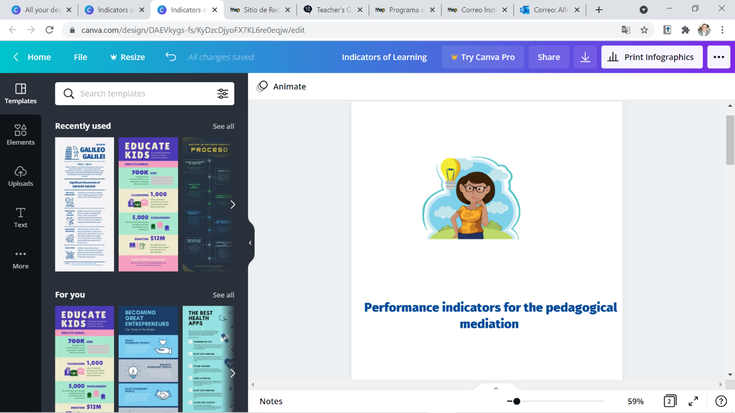

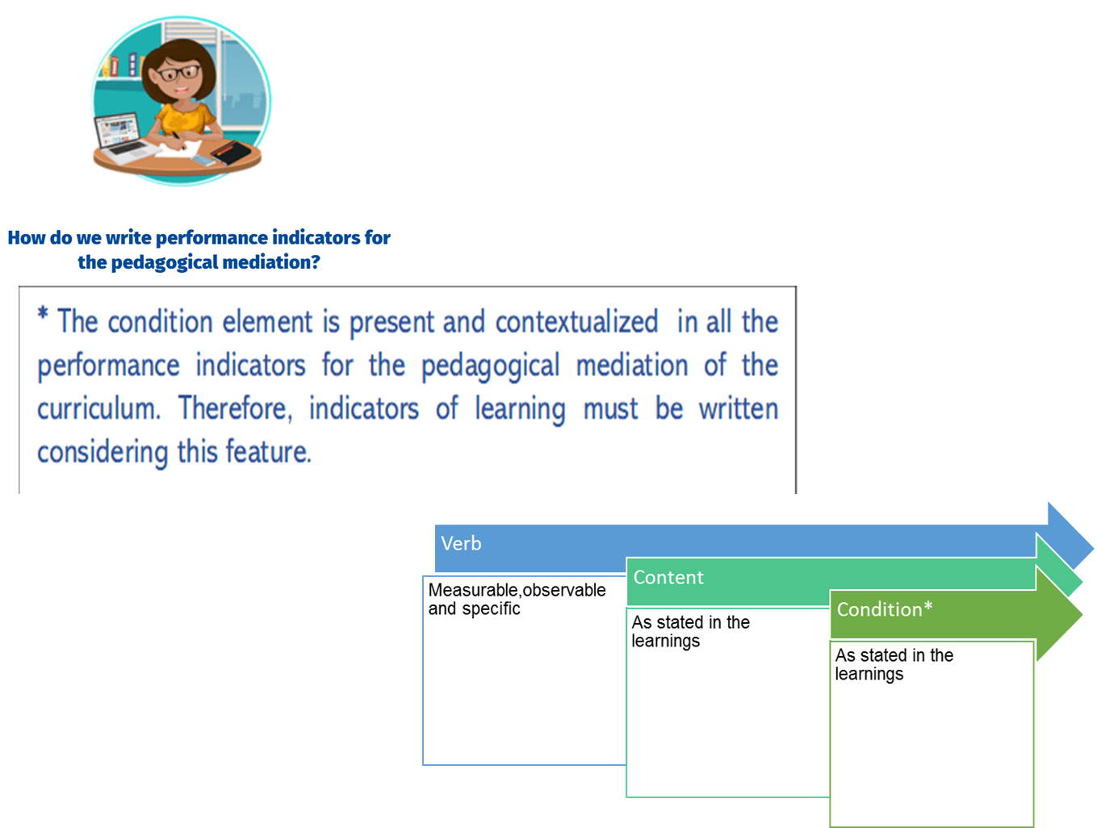

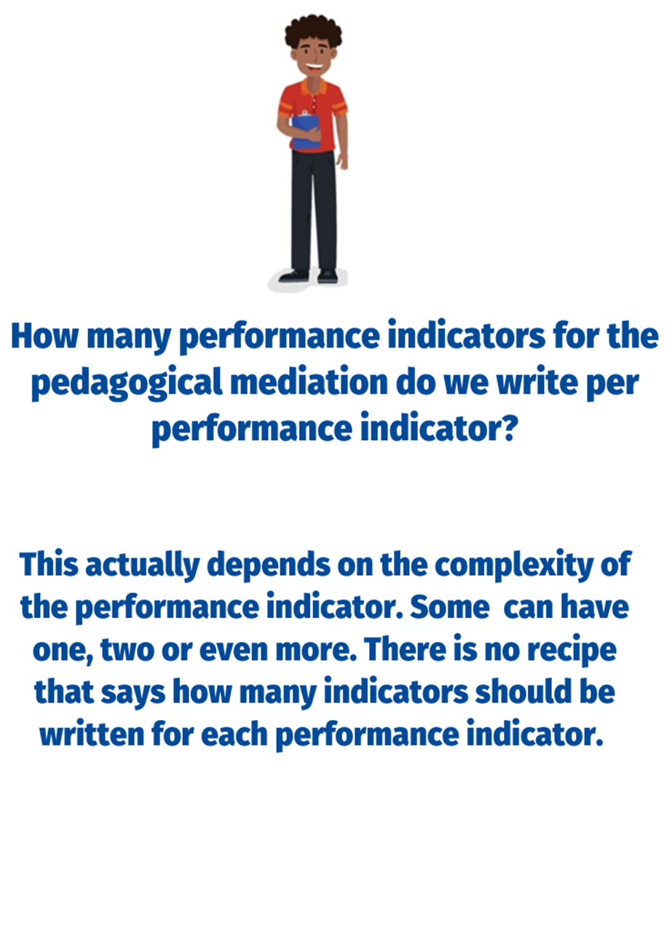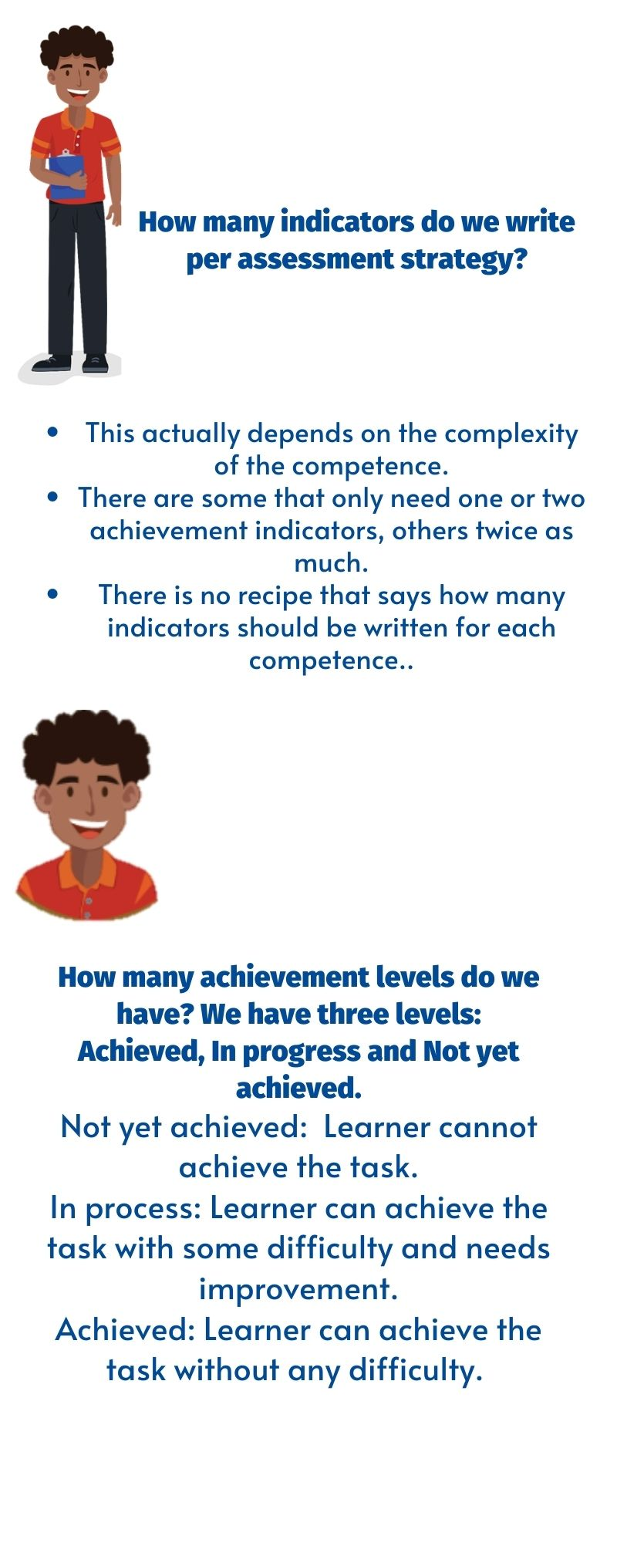

**10th Grade Performance Indicators for the Pedagogical Mediation**

The 10th Grade Literature in English Languagecurriculum provides performance indicators. These performance indicators are evidence that a teacher can record to show that students are achieving the learnings.

As classroom teachers, however, we do not simply assess students´ progress. We must guide students step by step through activities that enable them to reach the learnings.

This document breaks each performance indicator down into a number of specific performance indicators for the pedagogical mediation. They are the steps that learners follow to achieve the performance indicators. The performance Indicators for the pedagogical mediation have the following characteristics: measurable, observable and specific.

**How to use this document:**

1) Identify the performance indicator that you will be using.

2) Consider the steps or indicators for the pedagogical mediation learners need to follow to achieve each specific performance indicator.

3) Remember that there should be a connection between each performance indicator with the specific indicator for the pedagogical mediation proposed in this document.

4) Use specific indicators for the pedagogical mediation to monitor students’ progress and make the corresponding mediation changes if necessary.

**Important considerations:**

1. Indicators for the pedagogical mediation are organized in terms.
2. In some of the indicators proposed, teachers have to include the content of these indicators.
3. In most of the cases, indicators for the pedagogical mediation are arranged in a suggested order for students to perform them appropriately.
4. It is always necessary to use indicators for the pedagogical mediation, such as the ones suggested in this document. As educators, teachers must use their own professional judgement to identify the steps their students most need to take to achieve the learnings and that is reflected in the pedagogical mediation.
5. During the face- to- face and/or distance pedagogical mediation process, and therefore, at the end of each self-study guide, the teacher will use the indicators to create instruments (rubrics and /or performance scales) to assess students’ achievement level.
6. The mediation activities in the self-study guides must be coherent with the indicators for the pedagogical mediation to be included in the corresponding achievement level rubric.
7. When revising the indicators for the pedagogical mediation, consider that you can follow the steps below as suggested by the Institute of Collaborative Learning:

* **S**elect the activity and leave it as it is.
* **A**dapt it or change it somehow.
* **R**eject it. Choose not to use it
* **S**upplement it. Enrich the activity with extra material to make it more appropriate.

| Level: 10th  Terms: 1-2-3 | |
| --- | --- |
| Performance indicators from the program | Suggested Performance Indicators for the Pedagogical Mediation |
| Reacts to different oral and visual tasks (role plays, poems, songs, videos, dialogues and storytelling, among others). | Identifies the title (role plays, poems, songs, videos, dialogues and storytelling. |
| Recognizes the writer’s purpose by paying attention to the title. |
| Distinguishes images, techniques and literary figures. |
| Describes the artwork (oeuvre) including information about what, who, when, where, what it is about. |
| Reacts in a written / oral form towards the artwork (oeuvre). |
| Identifies some literary figures (metaphor, simile) | Gets the gist of myths, poetry and plays. |
| Identifies some literary figures (metaphor, simile) of myths, poetry and plays. |
| Identifies some elements of fiction (tone) | Gets the gist of myths, poetry and plays. |
| Identifies someelements of fiction (tone)in of myths, poetry and plays. |
| Produces poems (Sonnet-Sound Effects) | Prewrites ideas for lines and stanzas in a poem (Sonnet-Sound Effects). |
| Drafts lines and stanzas in a poem (Sonnet-Sound Effects). |
| Revises lines and stanzas in poems (Sonnet-Sound Effects)by looking for mistakes. |
| Edits poems (Sonnet-Sound Effects) by correcting the mistakes before publishing them. |
| Writes an integrated project based on literary pieces (novel) | Prewrites ideas for the situation/ problem, rising action, climax, falling action, and resolution of a novel. |
| Drafts sentences for the problem/ situation, rising action, climax, falling action, and resolution of a novel. |
| Revises the novel by looking for mistakes. |
| Edits the novel by correcting the mistakes before publishing. |
| Discriminates main ideas and specific details in a variety of oral and written passages. | Identifies the topic in a variety of oral, visual, and written passages. |
| Identifies main ideas in a variety of oral, visual, and written passages. |
| Extracts details in a variety of oral, visual, and written passages. |
| Recognizes a variety of short literary passages. | Gets the gist of short literary passages. |
| Identifies the structure of short literary passages. |
| Recognizes specific traits of short literary passages. |
| Distinguishes meaning in context. | Identifies written and spoken forms of vocabulary. |
| Recognizes the different meanings of the same word by using the context. |
| Expresses ideas, feelings, likes, dislikes, preferences, opinions, hypotheses and using appropriate vocabulary in oral and written oral forms. | Plans a set of ideas to express ideas, feelings, likes and dislikes, preferences, and opinions hypotheses using appropriate vocabulary in oral and written forms towards the artwork (oeuvre). |
| Makes complete sentences to express ideas, feelings, likes and dislikes, preferences, and opinions hypotheses using appropriate vocabulary in oral and written forms towards the artwork (oeuvre). |
| Expresses ideas, feelings, likes, dislikes, preferences, opinions, hypotheses and using appropriate vocabulary in oral and written oral forms. |
| Defends arguments using appropriate vocabulary in oral and written oral forms. | Plans a set of ideas to defend arguments using appropriate vocabulary in oral and written forms towards the artwork (oeuvre). |
| Makes complete sentences to defend arguments using appropriate vocabulary in oral and written forms towards the artwork (oeuvre). |
| Defends arguments using appropriate vocabulary in oral and written forms towards the artwork (oeuvre). |
| Compares different literary passages (novels). | Skims for the gist of different novels. |
| Scans different novels to find the events. |
| Recognizes the consequences from the events in different literary passages. |
| States similarities in events and consequences in different novels. |
| Contrasts different literary passages (novels). | Skims for the gist of different novels. |
| Scans different novels to find the events. |
| Recognizes the consequences from the events in different novels. |
| States differences in events and consequences of different novels. |
| Persuade audience. | States a position or claim to persuade the audience. |
| Lists main reasons or arguments to persuade the audience. |
| Describes facts and examples as evidence to persuade the audience. |
| Summarizes the most important details of the argument and what you want the audience to do. |

Propuesta elaborada por: Marianella Granados Sirias, Alfredo Ortega Cordero, Andrea Cruz Badilla. Asesores Nacionales de Inglés. **Departamento de Tercer Ciclo y Educación Diversificada. Dirección de Desarrollo Curricular** **References**

Common European Framework of Reference for Languages: Learning, Teaching, Assessment (2003). Cambridge, U.K.: Press Syndicate of the University of Cambridge.

Common European Framework of Reference for Languages: Learning, Teaching, Assessment (2018). Cambridge, U.K.: Press Syndicate of the University of Cambridge.

Ministerio de Educación Pública (2021). Lineamientos técnicos para el proceso de evaluación, curso lectivo 2021. San José, Costa Rica: MEP.

Ministerio de Educación Pública (2021). Mediación Pedagógica para la Educación Combinada, curso lectivo 2021. San José, Costa Rica: MEP.

Ministerio de Educación Pública (2011). Programa de Estudio de Literatura en Lengua Inglesa Liceos Experimentales Bilingües. San José, Costa Rica: MEP.

https://www.orientacionandujar.es/2016/11/06/taxonomia-robert-marzano-verbos-recomendados-indicadores-niveles-cognitivos/